

|  |
| --- |
| **[Benchtracker Procedures – Backend Users]** |
| May 2019 |
| Purpose is to provide procedures for the backend side of the Benchtrackers |
|  |





Table of Contents

What are the Benchtrackers? 2

What does Macro Do? 2

Limitations/Concerns 2

Short Procedures 3

Detailed Explanation of Process 4

Trouble Shooting 5

FAQ 5

File Explanations & Locations 6

Contacts: 6

## What are the Benchtrackers?

Benchtrackers are large excel files that recruiters maintain for people “on the bench” meaning they’re internal candidates that are ready to move to a new role and have already been vetted. They’re just waiting for a job to open, then they can be reassigned. Individuals reach out to ITEAM recruiters and give them details of where they want to work and what role they’re trying to get into, the recruiters then fill out that information about the candidate.

There are two Benchtrackers, they’re essentially mirrors of each other, just one is only allowed to be given to the executive team recruiters. (You can see high level people wanting to move teams.)

The purpose of the spreadsheet was to replace their legacy quip trackers, where recruiters would have to look up each individual field (job level, title, business title, manager, on dev list etc.) and then populate the spreadsheet in addition to the candidate preferences. The formulas & macro does it automatically. The user just has to type in an employee id and everything else populates.

The tableau dashboards that connect into the data are basically an online way of sorting the data. Nothing complex.

**Normal Benchtracker Excel Link:**

\\share.amazon.com\sites\iTEAM2.0\ITEAM sharepoint\ITEAM Update Final.xlsx

**Tableau Link:**

<https://tableau.amznhr.com/#/workbooks/1283/views>

**Executive Benchtracker Excel LInk:**

\\share.amazon.com\sites\ExecutiveiTEAM2.0\Confidential HR Exec Bench Tracker\Executive and HR ITEAM Benchtracker.xlsx

**Tableau Link**:

<https://tableau.amznhr.com/#/workbooks/1637/views>

## What does Macro Do?

The macro pulls in the candidate info drop information which contains the files needed and it takes it from here and drops it the same file path where the benchtrackers are housed. The two benchtrackers then use an index match based of the employee id and column headers to bring back the matching data.

I didn’t use VLOOKUP as it is much slower and the population is massive of possible candidates.

The macro then creates a backup of the benchtrackers for the day and then saves them in the backup folder on the sharepoint.

## Limitations/Concerns

Occasionally the excel sheets don’t refresh correctly and the data can become staled.

## Short Procedures

1. **Open up task scheduler > create a basic task > Name it something easy to find.**
   1. **(Windows search > Task Scheduler and it’ll come up.)**

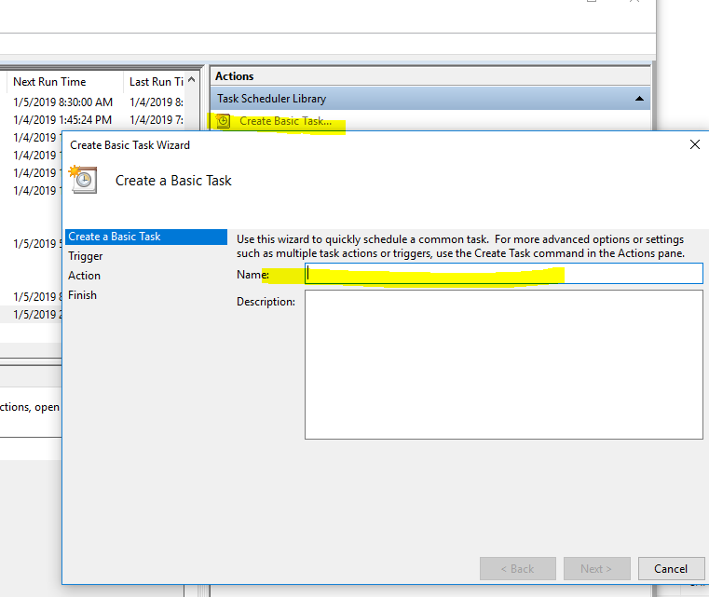

1. **Set the Trigger to Daily > Next > Depending on the timezone that you are in, if in EU, set it to be late afternoon. If in NA, set it to as soon as you arrive in office normally. Set to recur every day.**
2. **Click Start A Program**

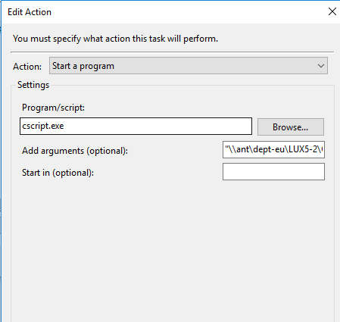

1. **In Program/Script put in - cscript.exe**
2. **Add Arguments (Optional) “**"\\ant\dept-eu\LUX5-2\Operations\EU-Ops-TA-Projects\Reporting\SHL Automation\MacrosandScripts\BenchTrackerTrigger.vbs"
   1. **Make sure you put the double quotes around it. Otherwise it will fail.**
3. **Hit Ok > Finish.**
4. **Macro will Run by itself as soon as the time period you specified above hits.**
5. **After you’ve gotten it setup, just have a calendar reminder set for a specific time in the day to remind you to refresh the benchtrackers, have it reoccur daily.**
6. **Open up >** **\\ant\dept-eu\LUX5-2\Operations\EU-Ops-TA-Projects\Reporting\ITEAMBenchtrackerFiledrop\**
   1. **Open either file > go to data > refresh all extracts**
   2. **Make sure number of records change or that you can see the extract date update.**
   3. **Do the same with the other file.**
   4. 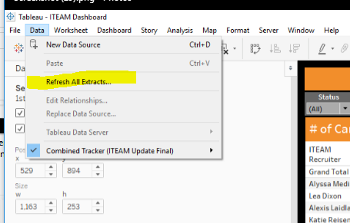
7. **Go server > publish workbook with the default settings.**
8. **Do the same with the other dashboard.**

## Detailed Explanation of Process

1. **An ICIMS/Peoplesoft extract is run daily using this ETL**  [**Benchtracker ETL**](https://datanet.amazon.com/dw-platform/servlet/dwp/template/EtlViewExtractJobs.vm/job_profile_id/6802493) **and is dropped into the input folder >** **Candidate Info Drop**
   1. The data is essentially an export of all candidates in Amazon that could theoretically transfer internally in Clark’s org.
2. **The macro then takes the text file from the drop and just drops it into the macro. It then resaves it as an excel file here >** 
   1. \\share.amazon.com\sites\iTEAM2.0\ITEAM sharepoint\
   2. \\share.amazon.com\sites\ExecutiveiTEAM2.0\Confidential HR Exec Bench Tracker\
3. **The macro then copies the benchtrackers to the relevant backup locations.**
4. **The benchtrackers then reference the updated candidate info drop – the main item that changes is if the person has recently been placed on a development plan.**
5. **Open up >** **\\ant\dept-eu\LUX5-2\Operations\EU-Ops-TA-Projects\Reporting\ITEAMBenchtrackerFiledrop\**
   1. **Open either file > go to data > refresh all extracts**
   2. **Make sure number of records change or that you can see the extract date update.**
   3. **Do the same with the other file.**
   4. 
6. **Go server > publish workbook with the default settings.**
7. **Do the same with the other dashboard.**

## Trouble Shooting

1. **Input files are not in the location.** 
   1. Go to the data drop link > \\Ant\dept\HR\HR_Recruiting\WW Ops & CS Reporting\ITEAM Data Drop
   2. If the file is not there > check to see if the ETL Failed

<https://datanet.amazon.com/dw-platform/servlet/dwp/template/EtlViewExtractJobs.vm/job_profile_id/6802493>

* 1. See if you’re getting an windows error message on loading the file. You’ll see a little red arrow in in your task bar for the windows upload center
  2. 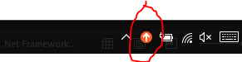
  3. 

1. **Task Scheduler Won’t Run**
   1. Ensure you’ve put double quotes around the arguments function.
   2. Also ensure that you’ve got access to that file location.
      1. Unselect run at highest privileges/run whether user is logged on or not.
2. **It won’t let me open the file from the above drive links?** 
   1. Use the below link, edit in excel then save it. (File > Edit in Excel >
   2. <https://share.amazon.com/sites/iTEAM2.0/_layouts/15/WopiFrame2.aspx?sourcedoc=%7B7e25f87e-4a3b-4b3a-b54d-6e04ea456b20%7D&action=edit&source=https%3A%2F%2Fshare.amazon.com%2Fsites%2FiTEAM2.0%2FSitePages%2FHome.aspx>
3. **Data Is pulling #REF**
   1. Open up the file itself > wait for it to load > edit in workbook and then just say yes when it requests you to update the links.

## FAQ

**Q.) Why are there 2 Benchtrackers?**

**A.)** It is due to the permissions. The main benchtracker (non-executive) is open to a large amount of people and can even be shared with outside contractors. The executive dashboard is for the executive iteam and it can display high level directors that are looking to move.

**Q.) Why are we not using QUIP anymore?**

**A.)** Quip stops working about 300 lines in, and then it becomes complex to manage and historically it would start splitting up

**Q.) User has a question about a field/tracker in general.**

A.) Check and see if their answer is answered here > \\ant\dept-eu\LUX5-2\Operations\EU-Ops-TA-Projects\Reporting\SHL Automation\MacrosandScripts\ITEAM Benchtracker User Procedures.docx

## File Explanations & Locations

**Macro Location:** **\\ant\dept-eu\LUX5-2\Operations\EU-Ops-TA-Projects\Reporting\SHL Automation\MacrosandScripts\**

* BenchtrackerMacro = Macro that does all of the above
* BenchtrackerTrigger = VBS script that basically opens the macro causing it to run. The VBS script is what the task scheduler is running.

**Input Files** - **\\Ant\dept\HR\HR_Recruiting\WW Ops & CS Reporting\ITEAM Data Drop\**

Candidate_info.txt = Peoplesoft export of all internal candidates. (The excel version is one that is created once the macro runs.)

**Output Files:**

1. **Non Executive -** **\\share.amazon.com\sites\iTEAM2.0\ITEAM sharepoint\**
2. Executive - **\\share.amazon.com\sites\ExecutiveiTEAM2.0\Confidential HR Exec Bench Tracker\**

**Backup Files:** (In case someone locks a file, deletes information etc.)

1. Non – Executive \\share.amazon.com\sites\iTEAM2.0\ITEAM sharepoint\Benchtracker Backup\
2. Executive - \\share.amazon.com\sites\ExecutiveiTEAM2.0\Confidential HR Exec Bench Tracker\Benchtracker Backup\

## Contacts:

N/A

ITEAM – Usually Amanda Emerick/Alex Irwin

Macro Creator / Macro Support– [jkjames@amazon.com](mailto:jkjames@amazon.com)

Process Owner - TBD